Chemistry 6 mark questions

CGP
Crude oil is a mixture of many different hydrocarbons.
It can be separated out into fractions using a fractionating column.
Describe how the process of separating crude oil using fractional distillation and explain how it works.
In this question you will be assessed on the quality of your English, the organisation of your ideas and your use of appropriate specialist vocabulary.

..................................................................................................................................................................................................................................................................................................................................................................................................................... .....................................................................................................................................................................................................................................................................................................................................................................................................................
.....................................................................................................................................................................................................................................................................................................................................................................................................................
.......................................................................................................................................
(6 marks)

Mark Scheme:
Crude oil is a mixture of many different hydrocarbons. It can be separated out into fractions using a fractionating column. Describe how the process of separating crude oil using fractional distillation and explain how it works.
0 marks: No relevant points are made.
1-2 marks: A brief outline of the process of separating crude oil by fractional distillation is given. The answer contains little or no explanation of how the process works.
3-4 marks: Some description of the process of separating crude oil by fractional distillation is given. The answer contains some explanation of how the process works. The answer has a logical structure and spelling, grammar and punctuation are mostly correct.
5-6 marks: A clear and detailed description of the process of separating crude oil by fractional distillation is given. The answer contains a full explanation of how the process works. The answer has a logical structure and uses correct spelling, grammar and punctuation.
Here are some points your answer may include:
Crude oil is heated until it turns into a gas. The gases enter a fractionating column.
A fractionating column has a temperature gradient. It is hot at the bottom and cold at the top.
The large hydrocarbons have high boiling points, so they turn back into liquids early on and drain out near the bottom of the column.
The small hydrocarbons have low boiling points, so they turn back into liquids near the top of the column, where it is cooler.
This separates the oil out into fraction. Each fraction contains a mixture of hydrocarbons with similar boiling points.
The large hydrocarbons have high boiling points because they have strong intermolecular forces holding their molecules together, so lots of energy is needed to overcome these forces.
The small hydrocarbons have lower boiling points because they have weaker intermolecular forces holding their molecules together. Not as much energy is needed to overcome these forces.
CGP
The Earth’s atmosphere has evolved gradually over billions of years.
Describe one theory for how the present day atmosphere evolved to have its current levels of oxygen, nitrogen and carbon dioxide.
In this question you will be assessed on the quality of your English, the organisation of your ideas and your use of appropriate specialist vocabulary.

..................................................................................................................................................................................................................................................................................................................................................................................................................... .....................................................................................................................................................................................................................................................................................................................................................................................................................
.....................................................................................................................................................................................................................................................................................................................................................................................................................
.......................................................................................................................................
(6 marks)

Mark Scheme:
The Earth’s atmosphere has evolved gradually over billions of years.
Describe one theory for how the present day atmosphere evolved to have its current levels of oxygen, nitrogen and carbon dioxide.
0 marks: No relevant points are made.
1-2 marks: A brief outline of how the present day atmosphere evolved, with reference to at least one of carbon dioxide, nitrogen and oxygen.
3-4 marks: Some description of how the present day atmosphere evolved with reference to at least two of carbon dioxide, nitrogen and oxygen. The answer has a logical structure and spelling, grammar and punctuation are mostly correct.
5-6 marks: A clear and detailed description of how the present day atmosphere evolved, with reference to carbon dioxide, nitrogen and oxygen. The answer has a logical structure and uses correct spelling, grammar and punctuation.
Here are some points your answer may include:
Volcanic eruptions released gases from inside the Earth. This degassing released mainly carbon dioxide but also steam and ammonia. When things settle down the early atmosphere was mostly carbon dioxide and water vapour.
The water vapour condensed to form the oceans.
A lot of the carbon dioxide dissolved into the oceans.
Green plants evolved. As they photosynthesised they removed carbon dioxide and produced oxygen.
Thanks to the plants the amount of oxygen in the air built up. Much of the carbon dioxide got locked up in sedimentary rocks and fossil fuels.
Nitrogen gas was put into the atmosphere by ammonia reacting with oxygen, and nitrogen gas being released by denitrifying bacteria. Nitrogen gas gradually built up in the atmosphere because it is unreactive, so it was being made but not broken down.

Jun 2012 C1B1P1 - Foundation

Mark Scheme:

Jun 2012 B1C1P1 – Higher

Mark Scheme:

Jun 2012 C1C2C3 – Foundation

Mark Scheme:
Jun 2012 C1C2C3 – Higher
Mark Scheme:

B1C1P1 Specimen - F

Cracking is a process that is done in an oil refinery.
Look at the table of information about different fractions found in crude oil.
The fractions contain hydrocarbon molecules.
The fractions at the top of the table have smaller molecules than the fractions at the bottom.
fraction | amount supplied in crude oil in tonnes | amount needed in tonnes
liquefied petroleum gases | 13 | 12
petrol | 10 | 15
diesel | 10 | 18
paraffin | 25 | 20
heating oil | 20 | 25
bitumen | 22 | 10
Crude oil contains too much of some fractions and not enough of other fractions.
The manager of the oil refinery needs to make some decisions.
She needs to decide the conditions to use and the fractions to be cracked.
What conditions should the manager use and how does she use the information in the table to decide which fractions should be cracked?
 The quality of written communication will be assessed in your answer to this question.
............................................................................................................................................................
............................................................................................................................................................
............................................................................................................................................................
............................................................................................................................................................
............................................................................................................................................................
............................................................................................................................................................
............................................................................................................................................................
............................................................................................................................................................
............................................................................................................................................................
............................................................................................................................................................
....................................................................................................................................................... [6]
[Total: 6]

Mark Scheme:
Level 3  Answer identifies both conditions needed for cracking and applies knowledge of cracking to explain that the decision should be based on both matching supply and demand and molecule size, with examples given from the table. All information in answer is relevant, clear, organised and presented in a structured and coherent format. Specialist terms are used appropriately. Few, if any, errors in grammar, punctuation and spelling.  (5-6 marks)  Level 2  Answer identifies at least one correct condition and applies limited knowledge of cracking to explain why at least one fraction from the table could be cracked. For the most part the information is relevant and presented in a structured and coherent format. Specialist terms are used for the most part appropriately. There are occasional errors in grammar, punctuation and spelling.  (3-4 marks)  Level 1  Answer includes one condition and some idea about using cracking to make more useful products. Answer may be simplistic. There may be limited use of specialist terms. Errors of grammar, punctuation and spelling prevent communication of the science.  (1-2 marks)  Level 0  Insufficient or irrelevant science. Answer not worthy of credit.  (0 marks) | 6 | relevant points include:  - cracking needs a high temperature / heating  - cracking needs a catalyst / use of zeolite  - cracking converts large hydrocarbon molecules into smaller ones  - cracking converts less useful hydrocarbons into more useful hydrocarbons  - cracking converts named fractions that are in excess into named fractions that are in short supply e.g. bitumen or paraffin into petrol or diesel  - the table shows that petrol and diesel are in short supply  - the table shows that bitumen and paraffin are in excess and that these are large molecules

B1C1P1 Specimen – H

Cracking is an important reaction that takes place within an oil refinery.
Cracking converts large hydrocarbon molecules into more useful smaller hydrocarbon molecules.
Look at the displayed formula for hexadecane.
The cracking of hydrocarbons, such as hexadecane, produces many different products and is a very important reaction in an oil refinery.
Explain why using chemical equations.
 The quality of written communication will be assessed in your answer to this question.
............................................................................................................................................................
............................................................................................................................................................
............................................................................................................................................................
............................................................................................................................................................
............................................................................................................................................................
............................................................................................................................................................
............................................................................................................................................................
............................................................................................................................................................
............................................................................................................................................................
............................................................................................................................................................
............................................................................................................................................................
............................................................................................................................................................
............................................................................................................................................................
........................................................................................................................................................[6]
[Total: 6]

Mark Scheme
Applies understanding of cracking to explain, using symbol equations, the possible products made during cracking of hexadecane including a clear indication as to why cracking can make many products. All information in answer is relevant, clear, organised and presented in a structured and coherent format. Specialist terms are used appropriately. Few, if any, errors in grammar, punctuation and spelling.  (5-6 marks)  Level 2  Limited application of understanding of cracking to explain, using word or symbol equations, the importance of some of the products formed. For the most part the information is relevant and presented in a structured and coherent format. Specialist terms are used for the most part appropriately. There are occasional errors in grammar, punctuation and spelling.  (3-4 marks)  Level 1  Answer attempts an explanation to include at least one reason for cracking and an idea of possible products. Answer may be simplistic. There may be limited use of specialist terms. Errors of grammar, punctuation and spelling prevent communication of the science.  (1-2 marks)  Level 0  Insufficient or irrelevant science. Answer not worthy of credit.  (0 marks) | 6 | relevant points include:  - Cracking produces smaller alkene and alkane molecules  - Cracking produces hydrogen  - The alkenes made are a source of polymers  - The alkanes made can be used as petrol  - Cracking enables oil refinery to balance supply with demand  - Equations can be word or symbol equations e.g.  hexadecane → octane + octene  C16H34 → C8H18 + C8H16  - Equations can use molecular, structural or displayed formulae  - Get many products because any of the carbon-carbon bonds in hexadecane can break

B1C1P1 Jan 2012 - F

Mark Scheme:

B1C1P1 Jan 2012 – H

Mark Scheme:

C1C2C3 Jan 2012 – F

Mark Scheme
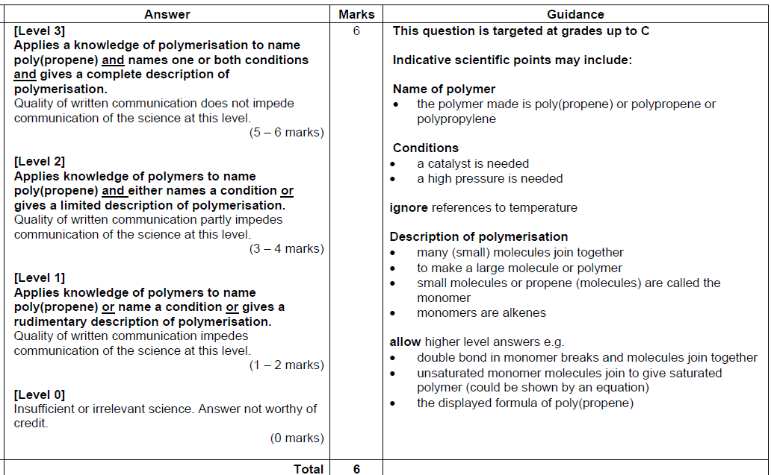

C1C2C3 Jan 2012 – H

Mark Scheme
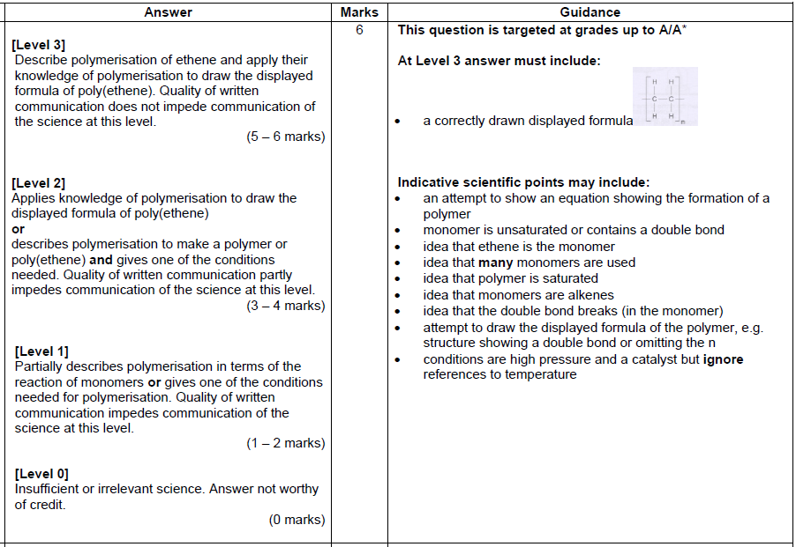

CGP
Describe how electrolysis is used to purify copper.
In your answer you should construct the equations for the oxidation and reduction reactions that happen at the anode and the cathode.
In this question you will be assessed on the quality of your English, the organisation of your ideas and your use of appropriate specialist vocabulary.

..................................................................................................................................................................................................................................................................................................................................................................................................................... .....................................................................................................................................................................................................................................................................................................................................................................................................................
.....................................................................................................................................................................................................................................................................................................................................................................................................................
.......................................................................................................................................
(6 marks)

Mark Scheme:
Describe how electrolysis is used to purify copper.
In your answer you should construct the equations for the oxidation and reduction reactions that happen at the anode and the cathode.
0 marks: No relevant points are made.
1-2 marks: A brief description of how electrolysis is used to purify copper is given. An attempt is made to construct the oxidation and reduction equations but they’re both incorrect.
3-4 marks: Some description of how electrolysis is used to purify copper is given. An attempt is made to construct the oxidation and reduction equations, but they may not be entirely correct. The answer has a logical structure and spelling, grammar and punctuation are mostly correct.
5-6 marks: A clear and detailed explanation of how electrolysis is used to purify copper is given. The equation for both oxidation and reduction are constructed correctly. The answer has a logical structure and uses correct spelling, grammar and punctuation.
Here are some points your answer may include:
Oxidation and reduction equations:
Oxidation (at the anode): Cu Cu²⁺ + 2e⁻
Reduction (at the cathode): Cu²⁺ + 2e⁻ Cu
How the process works:
A piece of impure copper is used as the anode.
A small piece of pure copper is used as the cathode.
Copper sulphate solution is used as the electrolyte.
When the current flows, electrons are pulled off the copper atoms at the anode. They go into solution as Cu²⁺ ions. The anode loses mass as the impure copper dissolves.
At the cathode Cu²⁺ ions gain electrons to become copper atoms. The cathode gains mass as pure copper is deposited there.
The impurities are left as a sludge at the bottom of the tank.
CGP
Ammonia can be produced using the Haber process. This process uses the elements nitrogen and hydrogen to make ammonia.
The table below shows the conditions that are used for the Haber process in industry.
Pressure | High (200 atmospheres)
Temperature | 450ºC
Catalyst | Iron

Explain why these conditions are used in the Haber process.
In this question you will be assessed on the quality of your English, the organisation of your ideas and your use of appropriate specialist vocabulary.

..................................................................................................................................................................................................................................................................................................................................................................................................................... .....................................................................................................................................................................................................................................................................................................................................................................................................................
.....................................................................................................................................................................................................................................................................................................................................................................................................................
.......................................................................................................................................
(6 marks)

Mark Scheme:
Ammonia can be produced using the Haber process. This process uses the elements nitrogen and hydrogen to make ammonia.
The table below shows the conditions that are used for the Haber process in industry.
Pressure | High (200 atmospheres)
Temperature | 450ºC
Catalyst | Iron
Explain why these conditions are used in the Haber process.
0 marks: No relevant points are made.
1-2 marks: A brief explanation is given of why at least one of the conditions in the table is used in the Haber process.
3-4 marks: Some explanation is given of why at least two of the conditions in the able are used in the Haber process. The answer has a logical structure and spelling, grammar and punctuation are mostly correct.
5-6 marks: A clear and detailed explanation is given of why all three of the conditions in the table are used in the Haber process. The answer has a logical structure and uses correct spelling, grammar and punctuation.
Here are some points your answer may include:
Pressure:
A high pressure is used because high pressure favours the forward reaction (producing ammonia from nitrogen and hydrogen).
Using a high pressure increases the percentage yield of ammonia.
Temperature:
High temperature favours the reverse reaction (where ammonia breaks up into nitrogen and hydrogen).
Using high temperatures would decrease the percentage yield of ammonia.
However, lowering the temperature would slow the reaction rate down too much.
450oC is a compromise/the optimum temperature. It gives a fast reaction rate and a reasonable percentage yield.
Catalyst:
The iron catalyst increases the rate of reaction, which gets it to the equilibrium proportions more quickly.
Without the catalyst, the temperature would have to be raised to increase the reaction rate. Doing this would decrease the percentage yield of ammonia.
Jun2012 B2C2P2 – Foundation

Mark Scheme:
Jun 2012 B2C2P2 – Higher

Mark Scheme:

Jun 2012 C1C2C3 – Foundation

Mark Scheme:
Jun 2012 C1C2C3 – Higher
Mark Scheme:

B2C2P2 Specimen F

Mark Scheme:
Level 3  Detailed description of Earth structure, including all the main parts of the Earth, and the effects of plate movement. All information in answer is relevant, clear, organised and presented in a structured and coherent format. Specialist terms are used appropriately. Few, if any, errors in grammar, punctuation and spelling.  (5-6 marks)  Level 2  Limited description of Earth structure with some reference to the effects of plate movement. For the most part the information is relevant and presented in a structured and coherent format. Specialist terms are used for the most part appropriately. There are occasional errors in grammar, punctuation and spelling.  (3-4 marks)  Level 1  Identifies some parts of the Earth and recognises that tectonic plates move. Answer may be simplistic. There may be limited use of specialist terms. Errors of grammar, punctuation and spelling prevent communication of the science.  (1-2 marks)  Level 0  Insufficient or irrelevant science. Answer not worthy of credit.  (0 marks) | 6 | Relevant points include:  Earth is a sphere  Earth is made up of core, thin, rocky crust and mantle  core contains iron  beneath the surface there is molten rock called magma  tectonic plates move (very slowly or about 2.5cm per year)  tectonic plate movement causes volcanoes  tectonic plate movement causes earthquakes  idea of over millions of years movement results in the formation of continents  allow tectonic plate movement causes mountain ranges to be formed  allow higher level answers involving convection currents in the mantle, that crust is less dense than the mantle or a description of the lithosphere

B2C2P2 Specimen H

The surface of the Earth is made up of tectonic plates.
The plates move very slowly.
A process called subduction can happen at plate boundaries.

Describe the theory of plate tectonics and use it to explain how subduction happens.
 The quality of written communication will be assessed in your answer to this question.
.....................................................................................................................................................
.....................................................................................................................................................
.....................................................................................................................................................
.....................................................................................................................................................
.....................................................................................................................................................
.....................................................................................................................................................
.....................................................................................................................................................
.....................................................................................................................................................
.....................................................................................................................................................
.....................................................................................................................................................
.....................................................................................................................................................
.....................................................................................................................................................
.................................................................................................................................................[6]

Mark Scheme:
Level 3  A comprehensive answer which accurately describes convection currents in the mantle and gives a thorough explanation of subduction. All information in answer is relevant, clear, organised and presented in a structured and coherent format. Specialist terms are used appropriately. Few, if any, errors in grammar, punctuation and spelling.  (5-6 marks)  Level 2  Answer describes how plates move and gives a partial explanation of subduction, recognising the types of plate involved. For the most part the information is relevant and presented in a structured and coherent format. Specialist terms are used for the most part appropriately. There are occasional errors in grammar, punctuation and spelling.  (3-4 marks)  Level 1  A simplistic description, which recognises the relative densities of tectonic plates and the mantle and attempts a simplistic explanation of subduction. There may be limited use of specialist terms. Errors of grammar, punctuation and spelling prevent communication of the science.  (1-2 marks)  Level 0  Insufficient or irrelevant science. Answer not worthy of credit.  (0 marks) | 6 | Relevant points include:  lithosphere made of tectonic plates  energy transfer through convection currents in the semi-rigid mantle causing plate movement  tectonic plates less dense than mantle  oceanic crust more dense than continental crust  collision between oceanic plates and continental plates leads to subduction  subduction is one plate going underneath the other  partial melting occurs  plates cooler at ocean

C1C2C3 – Jan 2012 – F

Mark Scheme
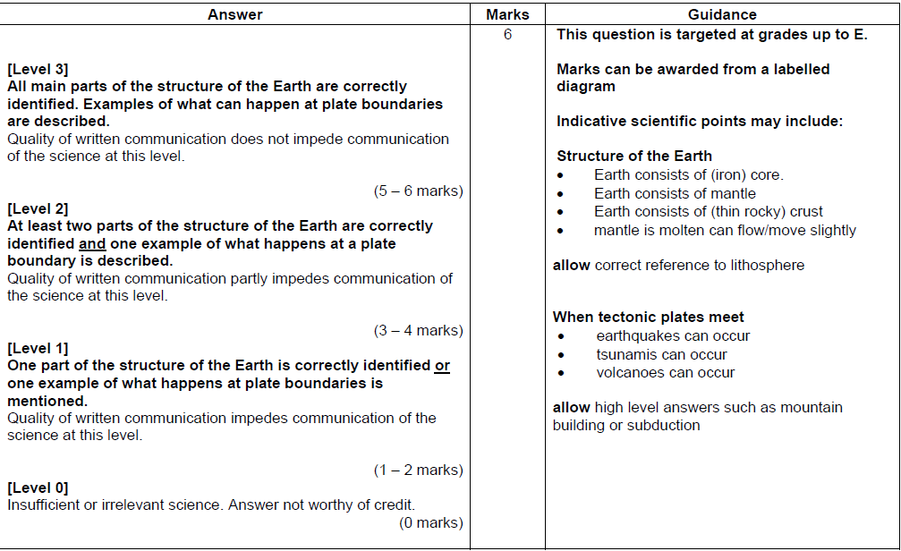

C1C2C3 Jan 2012 – H

Mark Scheme

CGP
The table below contains information about some of the properties of diamond and graphite.
 | Hardness | Melting point | Conducts electricity?
Diamond | Hard | High | No
Graphite | Soft | High | Yes

Explain these properties of diamond and graphite in terms of their structure and bonding.
In this question you will be assessed on the quality of your English, the organisation of your ideas and your use of appropriate specialist vocabulary.

..................................................................................................................................................................................................................................................................................................................................................................................................................... .....................................................................................................................................................................................................................................................................................................................................................................................................................
.....................................................................................................................................................................................................................................................................................................................................................................................................................
.......................................................................................................................................
(6 marks)

Mark Scheme:
The table below contains information about some of the properties of diamond and graphite.
 | Hardness | Melting point | Conducts electricity?
Diamond | Hard | High | No
Graphite | Soft | High | Yes

Explain these properties of diamond and graphite in terms of their structure and bonding.
0 marks: No relevant points are made.
1-2 marks: A brief attempt is made to explain one or two of these properties in terms of structure and bonding.
3-4 marks: Some explanation of three of four of the properties, in terms of their structure and bonding is given. The answer has a logical structure and spelling, grammar and punctuation are mostly correct.
5-6 marks: A clear and detailed explanation of five or all of the properties, in terms of their structure and bonding, is given. The answer has a logical structure and uses correct spelling, grammar and punctuation.
Here are some points your answer may include:
Diamond:
Each carbon atom in diamond forms four covalent bonds in a rigid giant covalent structure, which makes diamond really hard.
Because it is made up of lots of covalent bonds, which take a lot of energy to break, diamond has a very high melting point.
Each carbon atom in diamond forms four covalent bonds, so there are no free electrons. This is why diamond doesn’t conduct electricity.
Graphite:
Each carbon atom in graphite forms three covalent bonds, creating sheets of carbon atoms that can slide over each other. The carbon layers are only held together weakly, which is what makes graphite soft and slippery.
The covalent bonds between the carbon atoms, which take a lot of energy to break, give graphite a very high melting point.
Only three out of each carbon’s four outer electrons are used in bonds, so graphite has lots of free electrons and can conduct electricity.
CGP
Beth has a sample of pure ethanol. She decides to do an experiment t find out how much energy ethanol produces when it is burnt as a fuel.
Describe how Beth could carry out her experiment using a calorimeter.
In your answer give one way she could make her experiment reliable.
In this question you will be assessed on the quality of your English, the organisation of your ideas and your use of appropriate specialist vocabulary.

..................................................................................................................................................................................................................................................................................................................................................................................................................... .....................................................................................................................................................................................................................................................................................................................................................................................................................
.....................................................................................................................................................................................................................................................................................................................................................................................................................
.......................................................................................................................................
(6 marks)

Mark Scheme:
Beth has a sample of pure ethanol. She decides to do an experiment t find out how much energy ethanol produces when it is burnt as a fuel.
Describe how Beth could carry out her experiment using a calorimeter.
In your answer give one way she could make her experiment reliable.
0 marks: No relevant points are made.
1-2 marks: A brief description of how to carry out the calorimeter experiment is given. There is not mention of how to make the experiment more reliable.
3-4 marks: Some description of how to carry out the calorimeter experiment and how to make the experiment more reliable is given. The answer has a logical structure and spelling, grammar and punctuation are mostly correct.
5-6 marks: A detailed description of how to carry out the calorimeter experiment and how to make the experiment more reliable is given. The answer has a logical structure and uses correct spelling, grammar and punctuation.
Here are some points your answer may include:
The fuel/ethanol is placed in the spirit burner.
The burner and the fuel are weighed.
A set amount of water is measured out and put into a copper calorimeter.
The initial temperature of the water is measured.
The spirit burner is placed underneath the calorimeter and the fuel/ethanol is burnt.
Then the heat from the burner has made the water temperature rise by 20-30oC, the spirit burner is blown out and a note of the highest temperature the water reaches is taken.
The burner and the fuel are reweighed.
The experiment is repeated several times to make it reliable.

Jun 2012 B3C3P3 - Foundation

Mark Scheme:
Jun 2012 B3C3P3 – Higher
Mark Scheme:
Jun 2012 C1C2C3 – Foundation

Mark Scheme:

Jun 2012 C1C2C3 – Higher

Mark Scheme:

B3C3P3 Specimen – F

Mark Scheme:

B3C3P3 Specimen – H

Colin and Ann want the reaction to go faster.
They do not want to change the volume of acid or mass of zinc.
They say that they could:
• increase the temperature of the hydrochloric acid
• increase the concentration of the hydrochloric acid
• use powdered zinc instead of lumps of zinc.
Explain, using the reacting particle model, why two of these methods increase the rate of
this reaction.
 The quality of written communication will be assessed in your answer to this question.

.....................................................................................................................................................
.....................................................................................................................................................
.....................................................................................................................................................
.....................................................................................................................................................
.....................................................................................................................................................
.....................................................................................................................................................
.....................................................................................................................................................
.....................................................................................................................................................
.....................................................................................................................................................
.....................................................................................................................................................
.....................................................................................................................................................
.....................................................................................................................................................
................................................................................................................................................ [6]

Mark Scheme:

C1C2C3 Jan 2012 – F

Mark Scheme:
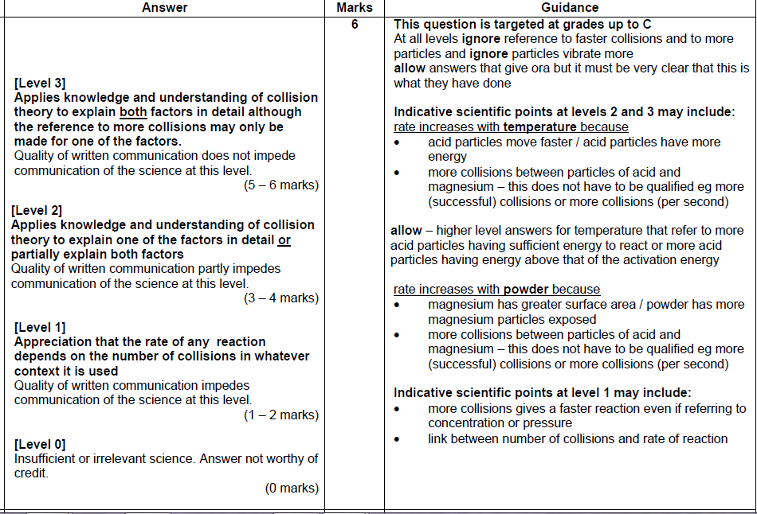

C1C2C3 Jan 2012 H

Mark Scheme:
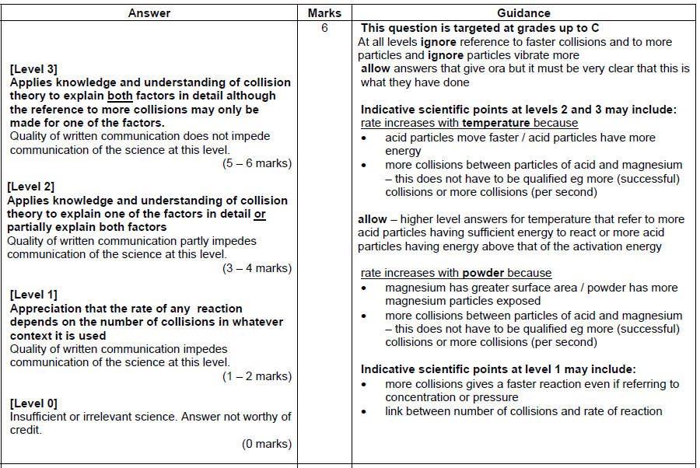

CGP
In 1864 Newlands first attempted to put the chemical elements into a table.
In 1869 Mendeleev created his own periodic Table of Elements.
Describe the evidence that Newlands and Mendeleev used to develop their tables. Explain how further evidence confirmed Mendeleev’s ideas.
In this question you will be assessed on the quality of your English, the organisation of your ideas and your use of appropriate specialist vocabulary.

..................................................................................................................................................................................................................................................................................................................................................................................................................... .....................................................................................................................................................................................................................................................................................................................................................................................................................
.....................................................................................................................................................................................................................................................................................................................................................................................................................
.......................................................................................................................................
(6 marks)

Mark Scheme:
In 1864 Newlands first attempted to put the chemical elements into a table.
In 1869 Mendeleev created his own periodic Table of Elements.
Describe the evidence that Newlands and Mendeleev used to develop their tables. Explain how further evidence confirmed Mendeleev’s ideas.
0 marks: No relevant points are made.
1-2 marks: A brief description of the evidence that Newlands or Mendeleev used to develop there table is given. An attempt is made to explain how one piece of further evidence confirmed Mendeleev’s ideas.
3-4 marks: Some description of the evidence that Newlands and Mendeleev used to develop their tables is given. The answer also includes some explanation of how two pieces of further evidence confirmed Mendeleev’s idea. The answer has a logical structure and spelling, grammar and punctuation are mostly correct.
5-6 marks: A clear and detailed description of the evidence that Newlands and Mendeleev used to develop their tables is given. The answer also includes a clear and detailed explanation of how three pieces of further evidence confirmed Mendeleev’s ideas. The answer has a logical structure and uses correct spelling, grammar and punctuation.
Here are some points your answer may include:
Newlands’ table:
Newlands noticed that every eighth element had similar properties, so he listed the known elements in rows of seven.
Mendeleev’s table:
Mendeleev put the element in order of atomic mass.
Mendeleev knew that some elements had similar properties so he left gaps to keep them in the same vertical groups.
Further evidence for Mendeleev’s table:
When new elements were discovered they fitted the patterns that Mendeleev had predicted.
He later discovery that each element has an atomic number one more than the previous element in the table fitted with his ideas.
The later discovery about the way that electrons are arranged in an atom (two in the first shell, eight in the second and third) matched the pattern Mendeleev’s table (two elements in the first row, eight in the second and third rows).

CGP
Sodium chloride has the following physical properties:
- High melting point.
- Lower melting point than magnesium oxide.
- It conducts electricity when dissolved in solution or when molten, but not when solid.
Explain these physical properties of sodium chloride in terms of structure and bonding.
In this question you will be assessed on the quality of your English, the organisation of your ideas and your use of appropriate specialist vocabulary.

..................................................................................................................................................................................................................................................................................................................................................................................................................... .....................................................................................................................................................................................................................................................................................................................................................................................................................
.....................................................................................................................................................................................................................................................................................................................................................................................................................
.......................................................................................................................................
(6 marks)

Mark Scheme:
Sodium chloride has the following physical properties:
- High melting point.
- Lower melting point than magnesium oxide.
- It conducts electricity when dissolved in solution or when molten, but not when solid.
Explain these physical properties of sodium chloride in terms of structure and bonding.
0 marks: No relevant points are made.
1-2 marks: A brief explanation of one of the physical properties of sodium chloride in terms of its structure and bonding given.
3-4 marks: Some explanation of at least two of the physical properties of sodium chloride in terms of its structure and bonding given. The answer has a logical structure and spelling, grammar and punctuation are mostly correct.
5-6 marks: A clear and detailed explanation of all three of the physical properties of sodium chloride in terms of its structure and bonding given. The answer has a logical structure and uses correct spelling, grammar and punctuation.
Here are some points your answer may include:
High melting point:
Sodium chloride has a giant ionic structure. There is a very strong attraction between the oppositely charged ions in the structure. To break bonds between the ions requires a lot of energy to overcome the attractive forces, so it has a high melting point.
Lower melting point than magnesium oxide:
Sodium chloride (NaCl) is made Na⁺ and Cl⁻ ions. Magnesium oxide MgO) is made of Mg²⁺ ions and O²⁻ ions, which have double the charge of the ions in sodium chloride. This means the attraction between the ions in sodium chloride is easier to overcome, so it has a lower melting point.
Cl⁻ ions are also larger than O²⁻ ions, so the ions in sodium chloride pack together less closely. This also makes the attraction between them easier to overcome and so sodium chloride has a lower melting point.

Properties of ionic substances - CR
- Lithium chloride, LiCl, has a lower melting point that Calcium oxide, CaO. Both conduct electricity when dissolved in water or molten, but not when solid.
Explain these properties in terms of the structure and bonding of each substance.
The quality of written communication will be assessed in your answer to this question.
..................................................................................................................................................................
..................................................................................................................................................................
..................................................................................................................................................................
..................................................................................................................................................................
..................................................................................................................................................................
..................................................................................................................................................................
..................................................................................................................................................................
..................................................................................................................................................................
..................................................................................................................................................................
..................................................................................................................................................................
..................................................................................................................................................................
..................................................................................................................................................................
..................................................................................................................................................................
..................................................................................................................................................................
..................................................................................................................................................................
..................................................................................................................................................................
..................................................................................................................................................................
..................................................................................................................................................................
..................................................................................................................................................................
..................................................................................................................................................................
..................................................................................................................................................................
..................................................................................................................................................................
..............................................................................................................................................[6 marks]
Mark Scheme:
Students could mention the following:
Electrical conductivity:
In solid LiCl and CaO the ions are fixed in place.
The ions cannot move around so cannot conduct electricity.
When molten or dissolved in solution the ions are free to move, so they can conduct electricity.
Melting points:
LiCl is made of Li⁺ and Cl⁻ ions.
CaO is made of Ca²⁺ and O²⁻ ions.
The ions in CaO have double the charge of the ions in LiCl.
The force of attraction between the ions in LiCl is therefore smaller than that in CaO (owing to the smaller charges).
The force of attraction between the ions in LiCl is therefore easier to overcome.
[Level 0]
Insufficient or irrelevant science. Answer not worthy of credit.
(0 marks)
[Level 1]
Explanation of the electrical conductivity of either LiCl or CaO when molten/dissolved or when solid given.
Quality of written communication impedes the communication of science at this level.
(1-2 marks)
[Level 2]
Explanation of the electrical conductivity of LiCl and CaO when molten/dissolved and when solid given. An attempt made to explain the difference in melting point between LiCl and CaO.
The answer has a logical structure and spelling, punctuation and grammar are mostly correct.
(3-4 marks)
[Level 3]
Detailed explanation of the electrical conductivity of LiCl and CaO when molten/dissolved and when solid given. Correct explanation of the difference in melting point between LiCl and CaO outlined.
The answer has a logical structure and uses correct spelling, punctuation and grammar.(5-6 marks)
Development of the Theory of the Atom – CR
- Explain the significance of the work of Dalton, J.J Thompson, Rutherford and Bohr in the development of the theory of atomic structure.
You may want to:
- State what each theory was.
- Describe how each model of the atom was different from the previous one.
- Explain the importance of any unexpected results in the development of the theory.

............................................................................................................................................
............................................................................................................................................
............................................................................................................................................
............................................................................................................................................
............................................................................................................................................
...........................................................................................................................................
...........................................................................................................................................
...........................................................................................................................................
...........................................................................................................................................
...........................................................................................................................................
...........................................................................................................................................
...........................................................................................................................................
...........................................................................................................................................
...........................................................................................................................................
...........................................................................................................................................
...........................................................................................................................................
...........................................................................................................................................
...........................................................................................................................................
...........................................................................................................................................
...........................................................................................................................................
...........................................................................................................................................[6 marks]
Mark scheme
History of the theory:
Dalton proposed that atoms of the same element were the same.
Dalton proposed that an atom could be split no further.
J.J Thompson discovered the electron.
Rutherford discovered an atom had a dense centre called the nucleus.
Bohr determined that electrons occupied orbitals.
How science works:
The theory changed as new evidence was found.
Science explanations are provisional but more convincing when predictions are later confirmed.
Geiger and Marsden’s (names not required) experiment led to unexpected results, which led to the theory of the nuclear atom.

[Level 0]
Insufficient or irrelevant science. Answer not worthy of credit. (0 marks)
[Level 1]
Two stages of the development of the theory of the atom (including names of scientists responsible) described correctly or one description of ‘how science works’ given.
Quality of written communication impedes the communication of science at this level.
(1-2 marks)
[Level 2]
All four stages of the development of the theory of the atom (including names of scientists responsible) described correctly and one description of ‘how science works’ given.
The answer has a logical structure and spelling, punctuation and grammar are mostly correct.
(3-4 marks)
[Level 3]
All four stages of the development of the theory of the atom (including names of scientists responsible) described correctly and one description of ‘how science works’ given.
In addition, an explanation of the effect of unexpected results on the theory given.
The answer has a logical structure and uses correct spelling, punctuation and grammar.
(5-6 marks)
Flame tests -CR
1. John and Leah do some flame tests.
They test the chemicals in three bottles.
One bottle contains sodium chloride, another potassium chloride and a third lithium chloride.
The labels are missing from the bottles.
John and Leah want to find out which chemical each bottle contains.

(a) Describe how they do a flame test.
You should include
• details of the equipment and the procedure used
• the results they would get for each chemical.
You may wish to draw a labelled diagram to help your answer.
The quality of written communication will be assessed in your answer to this question.

........................................................................................................................
........................................................................................................................
........................................................................................................................
........................................................................................................................
........................................................................................................................
........................................................................................................................
........................................................................................................................
........................................................................................................................
........................................................................................................................
........................................................................................................................
........................................................................................................................
[6 marks]

Mark scheme - this question only covers up to grade C material
Students could mention the following:

Moisten a flame test wire (wire loop/nichrome wire)with water or HCl.

Dip the flame test wire into the solid sample.

Place the flame test wire into a blue Bunsen flame.

Lithium will produce a red flame.

Sodium will produce a yellow flame.

Potassium will produce a lilac flame.

[Level 0]
Insufficient or irrelevant science. Answer not worthy of credit.
(0 marks)
[Level 1]
One aspect of the procedure correctly described or at least one flame colour correctly described.
Quality of written communication impedes the communication of science at this level.
(1-2 marks)
[Level 2]
Two or more aspects of the procedure correctly described and at least two flame colours correctly described,
The answer has a logical structure and spelling, punctuation and grammar are mostly correct.
(3-4 marks)
[Level 3]
All aspects of the procedure correctly described and all flame colours correctly described.
The answer has a logical structure and uses correct spelling, punctuation and grammar.
(5-6 marks)

B4C4P4 Specimen – F
Titanium, Ti, atomic number 22, is used to make the wings of some aeroplanes.
Predict four physical properties of titanium.
Explain why you make your predictions and relate the properties to the use of titanium in making aeroplane wings.
 The quality of written communication will be assessed in your answer to this question.
............................................................................................................................................................
............................................................................................................................................................
............................................................................................................................................................
............................................................................................................................................................
............................................................................................................................................................
............................................................................................................................................................
............................................................................................................................................................
............................................................................................................................................................
............................................................................................................................................................
............................................................................................................................................................
........................................................................................................................................................ [6]
[Total: 6]

Mark Scheme:

B4C4P4 Specimen – H

Describe and explain the relationship between atomic radii and melting points of the elements in Group 1. Include in your answer predictions for the atomic radius and melting point of rubidium.
The quality of written communication will be assessed in your answer to this question.
.....................................................................................................................................................
.....................................................................................................................................................
.....................................................................................................................................................
.....................................................................................................................................................
.....................................................................................................................................................
.....................................................................................................................................................
.....................................................................................................................................................
.....................................................................................................................................................
.....................................................................................................................................................
.....................................................................................................................................................
................................................................................................................................................ [6]
Mark Scheme

C4C5C5 specimen higher

Describe and explain the relationship between atomic radii and melting points of the elements in Group 1. Include in your answer predictions for the atomic radius and melting point of rubidium.
 The quality of written communication will be assessed in your answer to this question.

.....................................................................................................................................................
.....................................................................................................................................................
.....................................................................................................................................................
.....................................................................................................................................................
.....................................................................................................................................................
.....................................................................................................................................................
.....................................................................................................................................................
.....................................................................................................................................................
.....................................................................................................................................................
.....................................................................................................................................................
................................................................................................................................................ [6]

Mark Scheme

NC
Compare the reactivity patterns of reactivity in group 1 and group 7.
The quality of written communication will be assessed in your answer to this question.
..........................................................................................................................................................................................................................................
..........................................................................................................................................................................................................................................
..........................................................................................................................................................................................................................................
..........................................................................................................................................................................................................................................
..........................................................................................................................................................................................................................................
..........................................................................................................................................................................................................................................
..........................................................................................................................................................................................................................................
[6 marks]

Mark scheme - this question only covers up to grade C material
Students could mention the following:

Reactivity increases down group 1
Ease of losing an electron increases down group 1
Nuclear attraction down group one is weakened because nuclear radius increases, and electron shielding/number of shells increases.

Reactivity decreases down group 7
Ease of gaining an electron decreases
Nuclear attraction down group 7 decreases because nuclear radius increases, and electron shielding/number of shells increases.
[Level 0]
Insufficient or irrelevant science. Answer not worthy of credit.
(0 marks)
[Level 1]
Identifies the reactivity pattern of grp 1 as increasing down group one, and decreasing down group 7
Quality of written communication impedes the communication of science at this level.
(1-2 marks)
[Level 2]
Explaining either group 1 or 7, or describing the pattern in group 1 and 7
The answer has a logical structure and spelling, punctuation and grammar are mostly correct.
(3-4 marks)
[Level 3]
Explaining the reactivity pattern in both group 1 and 7.
The answer has a logical structure and uses correct spelling, punctuation and grammar.
(5-6 marks)

CGP
The contact process is used to make sulphuric acid.
One of the reactions involved in the contact process is shown below:
2SO_{2(g)} + O_{2(g)} 2SO_{3(G)}
This reaction is exothermic.
Describe the three conditions that are used in the contact process and explain why these conditions are used.
In this question you will be assessed on the quality of your English, the organisation of your ideas and your use of appropriate specialist vocabulary.

..................................................................................................................................................................................................................................................................................................................................................................................................................... .....................................................................................................................................................................................................................................................................................................................................................................................................................
.....................................................................................................................................................................................................................................................................................................................................................................................................................
.......................................................................................................................................
(6 marks)

Mark Scheme:
The contact process is used to make sulphuric acid.
One of the reactions involved in the contact process is shown below:
2SO_{2(g)} + O_{2(g)} 2SO_{3(G)}
This reaction is exothermic.
Describe the three conditions that are used in the contact process and explain why these conditions are used.
0 marks: No relevant points are made.
1-2 marks: A brief outline of one of the conditions used in the contact process is given. Little or no explanation of why the condition is used is given.
3-4 marks: A good description of at least two if the conditions used in the contact process is given. A brief explanation of why these conditions are used is also given. The answer has a logical structure and spelling, grammar and punctuation are mostly correct.
5-6 marks: A clear and detailed description of all three of the conditions used in the contact process is given. A full explanation of why these conditions are used is also given. The answer has a logical structure and uses correct spelling, grammar and punctuation.
Here are some points your answer may include:
Temperature:
The contact process is carried out at a temperature of 450oC.
Forming sulphur trioxide from sulphur dioxide is exothermic. So reducing the temperature will increase the yield of sulphur trioxide.
But reducing the temperature slows the reaction down.
A medium temperature of 450oC is used as a compromise – to get quite a high yield quite quickly.
Pressure:
The contact process is carried out at a pressure of 1 atmosphere.
There are two moles of product compared to three moles of reactant. So increasing the pressure would increase the yield of sulphur trioxide. But increasing the pressure is expensive, so atmospheric pressure is used.
Catalyst:
During the contact process a vanadium pentoxide (V₂O₅) catalyst is also used.
The catalyst increases the rate of reaction (but it doesn’t change the position of equilibrium).

CGP
Ryan carried out some simple tests on samples of 1 mol/dm³ hydrochloric acid and 1 mol/dm³ ethanoic acid. The results are shown in the table below.
Test | 1 mol/dm³  Hydrochloric acid | 1 mol/dm³  Ethanoic acid
pH from Universal indicator test | 0 | 2.4
Add magnesium ribbon | Gas bubbles released rapidly | Gas bubbles released slowly
Test for electrical conductivity | high | Moderate/low

Explain the differences in the results between hydrochloric acid and ethanoic acid for the tests that Ryan carried out.
In this question you will be assessed on the quality of your English, the organisation of your ideas and your use of appropriate specialist vocabulary.

..................................................................................................................................................................................................................................................................................................................................................................................................................... .....................................................................................................................................................................................................................................................................................................................................................................................................................
.....................................................................................................................................................................................................................................................................................................................................................................................................................
.......................................................................................................................................
(6 marks)

Mark Scheme:
Ryan carried out some simple tests on samples of 1 mol/dm³ hydrochloric acid and 1 mol/dm³ ethanoic acid. The results are shown in the table below.
Test | 1 mol/dm³  Hydrochloric acid | 1 mol/dm³  Ethanoic acid
pH from Universal indicator test | 0 | 2.4
Add magnesium ribbon | Gas bubbles released rapidly | Gas bubbles released slowly
Test for electrical conductivity | high | Moderate/low
Explain the differences in the results between hydrochloric acid and ethanoic acid for the tests that Ryan carried out.
0 marks: No relevant points are made.
1-2 marks: A brief attempt is made to explain one of the differences in the test results shown in the table.
3-4 marks: Some explanation is given of at least two of the difference in the test results shown in the table. The answer has a logical structure and spelling, grammar and punctuation are mostly correct.
5-6 marks: A clear and detailed explanation is given of all three differences in the test results shown in the table. The answer has a logical structure and uses correct spelling, grammar and punctuation.
Here are some points your answer may include:
pH:
Ethanoic acid has a higher pH than hydrochloric acid because it is a weaker acid. Strong acids ionise completely in water. This means every molecule of acid releases a hydrogen ion. Weak acids do not fully ionise. The pH of an acid is a measure of the concentration of H⁺ ions in the solution, so weaker acids will have a higher pH.
Reactivity:
Ethanoic acid reacted with the magnesium ribbon more slowly than hydrochloric acid because it has a lower concentration of H⁺ ions. This means that the collision frequency between the reactants was lower.
Electrical conductivity:
Ethanoic acid had a lower electrical conductivity than hydrochloric acid because it has a much lower concentration of ions. The ions carry the charge through acid solutions as they move more.
The lower the concentration of ions, the less charge can be carried.
Titration - CR
- Hydrochloric acid reacts with sodium hydroxide to form a salt and water.

  - Write a balanced symbol equation for this reaction.

..........................................................................................................................................
[1 mark]

  - Describe how you would carry out this neutralisation reaction in the laboratory.

You should give details of the equipment and the procedure used.

The quality of written communication will be assessed in your answer to this question.

...........................................................................................................................................

...........................................................................................................................................

...........................................................................................................................................

...........................................................................................................................................

...........................................................................................................................................

...........................................................................................................................................

...........................................................................................................................................

...........................................................................................................................................

...........................................................................................................................................

...........................................................................................................................................

...........................................................................................................................................

...........................................................................................................................................

...........................................................................................................................................

[6 marks]
Mark scheme – this question only covers up to high grade C material
Students could mention the following:

Pour the acid into the burette.

Measure the alkali using a pipette and pipette filler.

The pipette filler should be used to avoid contact with your skin.

Add a few drops of indicator solution to the conical flask.

Add the acid slowly to the alkali (or vice versa) until the colour of the indicator just changes/until the end point is reached.

Note the volume of acid (from the burette) used.

Repeat the titration until you have consistent/concordant results.

Consistent results needed for improved accuracy.

[Level 0]

Insufficient or irrelevant science. Answer not worthy of credit. (0 marks)

[Level 1]

Two pieces of equipment correctly spelt or a part of the method described.

Quality of written communication impedes the communication of science at this level.

(1 – 2 marks)
[Level 2]

Two or more pieces of equipment correctly spelt and the correct use of at least two of them in the method.
Safety feature of the pipette filler described.

Quality of written communication partly impedes communication of the science at this level.

(3 – 4 marks)
[Level 3]

Two or more pieces of equipment correctly spelt and the correct use of at least two of them in the method.
Safety feature of the pipette filler described.
Colour change of indicator/end point must be mentioned.
An explanation for the need for several consistent titre readings given.

Quality of written communication does not impede communication of the science at this level.

(5 – 6 marks)
C4C5C6 Specimen – Higher
Mark Scheme:

C4C5C6 Specimen – Foundation

...........................................................................................................................................

...........................................................................................................................................

...........................................................................................................................................

...........................................................................................................................................

...........................................................................................................................................

...........................................................................................................................................

...........................................................................................................................................

...........................................................................................................................................

...........................................................................................................................................

...........................................................................................................................................

...........................................................................................................................................

...........................................................................................................................................

...........................................................................................................................................

[6 marks]

Mark Scheme:
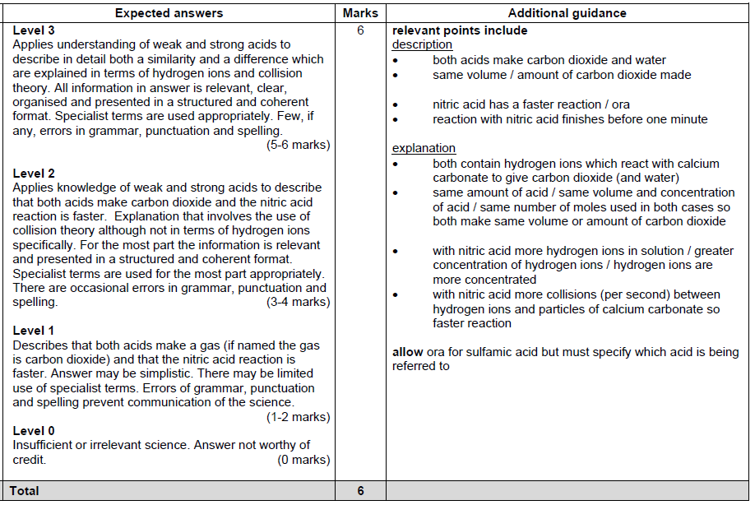

CGP
CFCs (chlorofluorocarbons) used to be used as coolants in refrigerators.
However, scientists realised that CFCs were damaging the atmosphere, so today alternatives to CFCs are used instead.
Describe how CFCs damage the atmosphere and explain why CFCs released in the past are still damaging the atmosphere today.
In this question you will be assessed on the quality of your English, the organisation of your ideas and your use of appropriate specialist vocabulary.

..................................................................................................................................................................................................................................................................................................................................................................................................................... .....................................................................................................................................................................................................................................................................................................................................................................................................................
.....................................................................................................................................................................................................................................................................................................................................................................................................................
.......................................................................................................................................
(6 marks)

Mark Scheme:
CFCs (chlorofluorocarbons) used to be used as coolants in refrigerators.
However, scientists realised that CFCs were damaging the atmosphere, so today alternatives to CFCs are used instead.
Describe how CFCs damage the atmosphere and explain why CFCs released in the past are still damaging the atmosphere today.
0 marks: No relevant points are made.
1-2 marks: A brief description f how CFCs damage the atmosphere is given. There is little or no explanation as to why CFCs released in the past are still damaging the atmosphere today.
3-4 marks: A good description of how CFCs damage the atmosphere is given. There is some explanation of why CFCs released in the past are still damaging the atmosphere today. The answer has a logical structure and spelling, grammar and punctuation are mostly correct.
5-6 marks: A clear and detailed description of how CFCs damage the atmosphere is given. There is a full explanation of why CFCs released in the past are still damaging the atmosphere today. The answer has a logical structure and uses correct spelling, grammar and punctuation.
Here are some points your answer may include:
How CFCs damage the atmosphere:
Ultraviolet light makes the carbon-chloride bonds in CFCs break to form free radicals.
This happens in the stratosphere where the ultraviolet light from the Sun is stronger.
Chlorine free radical (Cl●) from this reaction react with ozone (O3) turning it into ordinary oxygen molecule (O2) and chlorine oxide (ClO●).
The chlorine oxide molecule is very reactive, and reacts with ozone to make oxygen molecules and another free radical.
This chlorine ffree radical now goes on and reacts with another ozone molecule. This is a chain reaction, so just one chlorine free radical from one CFC molecule can break up lots of ozone molecules.
Why they are still damaging the atmosphere today:
CFCs are not very reactive, and will only break up to form chlorine atoms in the stratosphere, where there is lots of ultraviolet light around. This means that the CFCs in the stratosphere now will take a long time to be removed.
Each CFC molecule produces one chlorine atom which can react with many ozone molecules, so that CFC molecules that are present in the stratosphere now will continue to destroy ozone for a long time.

CGP
Ethanol can be produced through fermentation or by hydrating ethane.
Compare these two methods of producing ethanol. In your answer include the balanced symbol equation for each of these methods.
In this question you will be assessed on the quality of your English, the organisation of your ideas and your use of appropriate specialist vocabulary.

..................................................................................................................................................................................................................................................................................................................................................................................................................... .....................................................................................................................................................................................................................................................................................................................................................................................................................
.....................................................................................................................................................................................................................................................................................................................................................................................................................
.......................................................................................................................................
(6 marks)

Mark Scheme:
Ethanol can be produced through fermentation or by hydrating ethane.
Compare these two methods of producing ethanol. In your answer include the balanced symbol equation for each of these methods.
0 marks: No relevant points are made.
1-2 marks: A brief outline comparing one or two aspects of fermentation and hydration is given. An attempt is made to construct an equation for each method but they are both incorrect.
3-4 marks: Some description comparing three of four aspects of fermentation and hydration is given. An attempt is made to construct an equation for each method but they may not be entirely correct. The answer has a logical structure and spelling, grammar and punctuation are mostly correct.
5-6 marks: A clear and detailed description of at least five aspects of fermentation and hydration is given. The equation for each method is constructed correctly. The answer has a logical structure and uses correct spelling, grammar and punctuation.
Here are some points your answer may include:
Equations:
Fermentation: C₆H₁₂O₆ 2C₂H₅OH + 2CO₂
Hydration: C₂H₄ + H₂O C₂H₅OH
Comparison:
Fermentation is usually a batch process which is slow and inefficient. Ethane hydration uses a continuous process so the ethanol is made more quickly.
Hydration requires much harsher reaction conditions so is a more expensive process to run.
The ethanol made by fermentation is a renewable fuel. It is made from renewable resources e.g. sugar cane or sugar beets), so it won’t run out. The ethane used in the hydration reaction is a non-renewable fuel. It’s produced from crude oil, which will one day run out.
The ethanol made by fermentation isn’t very pure and has to be purified by distillation before it’s used. The ethanol made by hydration is of a much higher purity.
Fermentation has a lower atom economy than hydration, as not all of the reactants are used to make the ethanol.
The yield of a hydration reaction is very low but by recycling any unused reactants you can achieve yields of up to 95%. The yields achieved by using fermentation are much lower.
C4C5C6 Specimen Higher
..................................................................................................................................................................................................................................................................................................................................................................................................................... .....................................................................................................................................................................................................................................................................................................................................................................................................................
.....................................................................................................................................................................................................................................................................................................................................................................................................................
.......................................................................................................................................
(6 marks)

Mark Scheme

C4C5C6 Specimen Foundation

What conclusions can be drawn from these results?
Explain how each conclusion is supported by the data.
 The quality of written communication will be assessed in your answer to this question.
............................................................................................................................................................
............................................................................................................................................................
............................................................................................................................................................
............................................................................................................................................................
............................................................................................................................................................
............................................................................................................................................................
............................................................................................................................................................
............................................................................................................................................................
............................................................................................................................................................
............................................................................................................................................................
....................................................................................................................................................... [6]

Mark Scheme:
