History Transition work
Introduction
History challenges our assumptions in today, when you know history you are empowered to make sense of the now and question your own and others’ assumptions. Studying history at CGA will help you to understand the political, social and economic structures of the UK and the USA. Our course also explores the British Experience of Warfare from the 1790s, which enables you to understand and explore the role warfare played in forging the modern world. Throughout the units you will be expected to work with evidence in the form of historic sources and with modern historian’s interpretations of the past. Your ability to be critical and analytical will be honed over the course of the 2 year A Level.
To study history requires an inquisitive and open mind; a student who is willing and enthusiastic in reading, listening to podcasts and watching films/ documentaries. As you transition into year 12 take this opportunity to enrich your current understanding of 20th century Britain and USA in preparation for your paper 1 and 2 courses to start in September.
As part of your transition have a go at some of these different activities designed to prepare you for the next step.

Complete this MOOC.  This free online course explores the building blocks of our political views: freedom, community, place, justice and choice.  Propaganda and Ideology in Everyday Life  University of Nottingham and the British Library  Available now | Listen to this radio programme.  Comedy series that takes listeners back in time, feeding hashtags, trolls and trending topics into moments in History.  History Retweeted  BBC Programmes | Read this article.  This article pivots through 13.7 billion years of history, telling a story of how the world — against all odds — became a place of 7 billion humans interconnected in highly complex ways.  A history curriculum that starts at the beginning of time  Ideas TED
Listen to this radio programme.  History as told by the people who were there. There are hundreds of episodes with a new one every day.  Witness History  BBC Programmes | Watch this TED talk. Insightful talks that offer fresh, thoughtful perspectives on Black identity. This playlist has 23 different talks all exploring different aspects of black identity, culture and history.  Talks to celebrate Black History Month  TED Talk

TASK: sort the cards into the following categories: ​
- America vs Britain ​

Then within those...​
- Social ​
- Political ​
- Economic ​

Extension: can you add any more events which you consider to have had a great impact on USA or Britain.

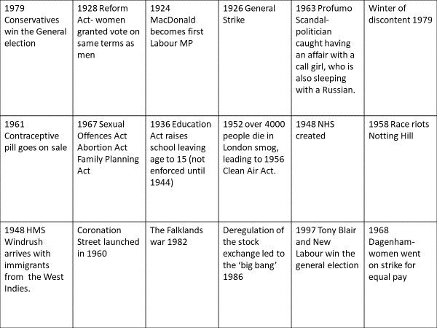

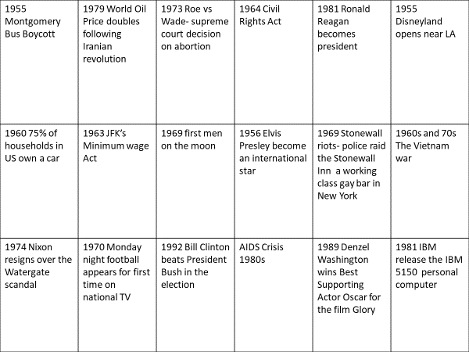

Reading, watching and listening
Britain Transformed
Title | Author | Resource type
Overview / Big Narrative
History of Modern Britain | Andrew Marr | Non-fiction
Small Island | Andrea Levy | Book
The Crown | Netflix | Drama series
How Britain Really Works, Stig Abell (History Hit) | Dan Snow | Podcast (+ accompanying book)
Mas Media Popular Culture and Social Change since 1945 | Stuart Clayton | Book
Thatcherism and British Politics: The End of Consensus? | Dennis A Kavanah | Book
Road to Wigan Pier | George Orwell | Book
Black and British: a Forgotten History | David Olusoga | Book
White Teeth | Zadie Smith | Book
Political environment
The Heart of Government: 100 Years of the Cabinet Office, Ben Gummer (History Hit) | Dan Snow | Podcast (+ accompanying book)
Clement Attlee, John Bew and Anna Whitelock (History Hit) | Dan Snow | Podcast (+ accompanying book)
The Cabinet of World War II, David Owen (History Hit) | Dan Snow | Podcast (+ accompanying book)
Women of Westminster | Dan Snow | Podcast (+ accompanying book)
Winston Churchill, Andrew Roberts (Histoty Hit) | Dan Snow | Podcast (+ accompanying book)
Economic environment
How Debt Made Nations Great, Martin Slater (History Hit) | Dan Snow | Podcast (+ accompanying book)
The Economics of WW2, Duncan Weldon (History Hit) | Dan Snow | Podcast (+ accompanying book)
Society
Windrush, Empire and the Legacy of Slavery, David Lammy (History Hit) | Dan Snow | Podcast (+ accompanying book)
The Empire Windrush, Alex Von Tunzelmann (History Hit) | Dan Snow | Podcast (+ accompanying book)
Security&Freedom in Britain at the Start of WW2, Henry Hemming (History Hit) | Dan Snow | Podcast (+ accompanying book)
Protest: Spirit of the People, Donald Macintyre (History Hit) | Dan Snow | Podcast (+ accompanying book)
Britain and Empire in 20th Centruy, David Edgerton (History Hit) | Dan Snow | Podcast (+ accompanying book)
The Unwanted: The secret Windrush Files | David Olusoga | BBC doc
Culture
When Football Banned Women, Clare Balding (History Hit) | Dan Snow | Podcast (+ accompanying book)
Life as a Woman in WW2, Eve Warton (History Hit) | Dan Snow | Podcast (+ accompanying book)
The Sexual Revolution, Virginia Nicholson (History Hit) | Dan Snow | Podcast (+ accompanying book)
Thatcher
Thatcher: A Very British Revolution | BBC | TV Documentary
Thatcher (History Hit) | Dan Snow | Podcast
Fall of the Iron Lady | Dan Snow | podcast

USA: conformity and challenge
Title | Author | Resource type
Political Polarisation in the USA, Joanne Freeman (History Hit) | Dan Snow | Podcast (+ accompanying book)
Strength to Love | Martin Luther King | Sermons
The 13th Amendment | Netflix/ YouTube  Ava DuVernay | Documentary
Selma | N/A | Film
The Long Civil Rights Movement and the Political Uses of the Past | Jacqueline Dowd Hall | Article
The Great Gatsby | F Scott Fitzgerald | Book
Of Mice and Men | John Steinbeck | Book
Mouth Full of Blood | Toni Morrison | Book
The Catcher in the Rye | J.D Sallinger | Book
Fear and Loathing in Las Vegas: a Savage Journey into the Heart of America | Hunter S Thompson | Book
Invisible Man | Ralph Ellison | Book
Death of A Salesman | Arthur Miller | Book
Streetcar Named Desire | Tennessee Williams | Book
I Know Why the Caged Bird Sings | Maya Angelou | Book
Who Killed Malcolm X | Netflix | Documentary series
1619 | Nikole Hannah-Jones | Podcast

Follow these useful links
https://www.nationalarchives.gov.uk/education/britain1906to1918/
https://www.ushistory.org/us/
https://www.myheplus.com/post-16/subjects/history

