Core Maths Reading List

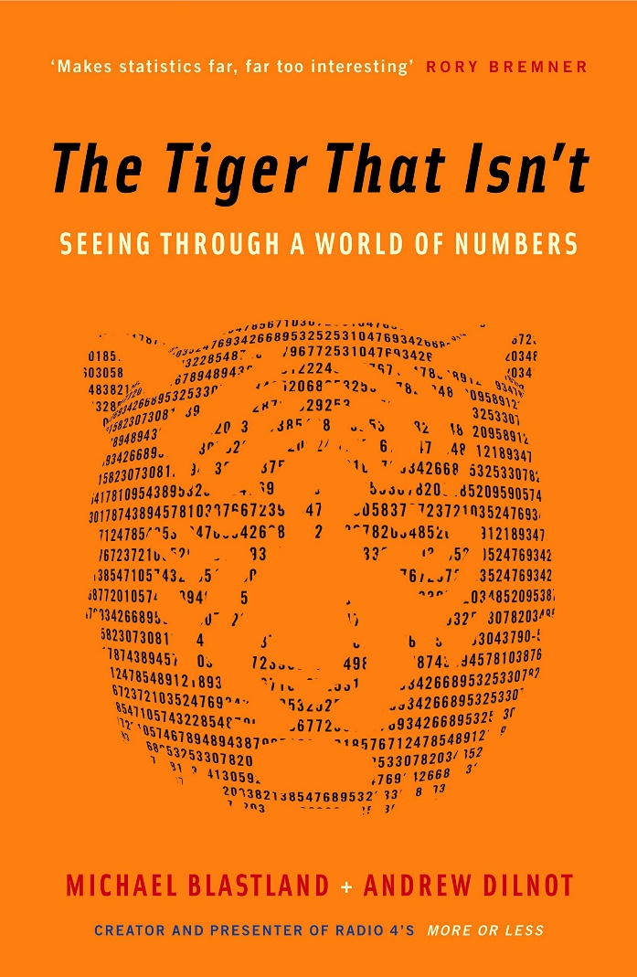
The Tiger That Isn’t: Seeing Through a World of Numbers by Andrew Dilnot
Mathematics scares and depresses most of us, but politicians, journalists and everyone in power use numbers all the time to bamboozle us. Most maths is really simple - as easy as 2+2 in fact. Better still it can be understood without any jargon, any formulas - and in fact not even many numbers. Most of it is commonsense, and by using a few really simple principles one can quickly see when maths, statistics and numbers are being abused to play tricks - or create policies - which can waste millions of pounds. It is liberating to understand when numbers are telling the truth or being used to lie, whether it is health scares, the costs of government policies, the supposed risks of certain activities or the real burden of taxes.

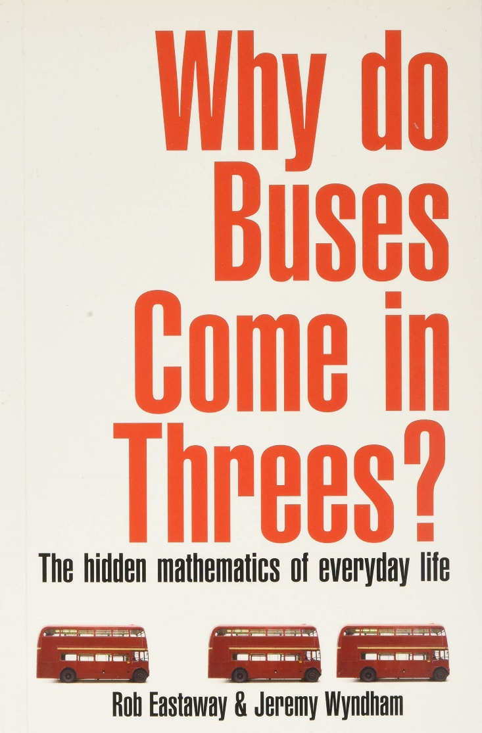
Why Do Buses Come in Threes?: The Hidden Maths of Everyday Life: The Hidden Mathematics of Everyday Life by Robin Eastaway and Jeremy Wyndham

With a foreword by Tim Rice, this book will change the way you see the world. Why is it better to buy a lottery ticket on a Friday? Why are showers always too hot or too cold? And what's the connection between a rugby player taking a conversion and a tourist trying to get the best photograph of Nelson's Column? These and many other fascinating questions are answered in this entertaining and highly informative book, which is ideal for anyone wanting to remind themselves - or discover for the first time - that maths is relevant to almost everything we do. Dating, cooking, travelling by car, gambling and even life-saving techniques have links with intriguing mathematical problems, as you will find explained here. Whether you have a PhD in astrophysics or haven't touched a maths problem since your school days, this book will give you a fresh understanding of the world around you.

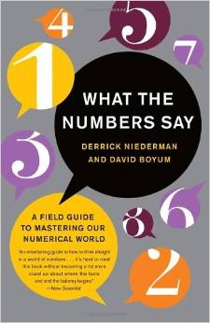
What the Numbers Say: A Field Guide to Mastering Our Numerical World by Derrick Niederman and David Boyum

This book looks at situations where it's important to be able to understand and analyse numerical information. Although many of the contexts are American, it is very readable and will be of particular interest to teachers and students of Core Maths.

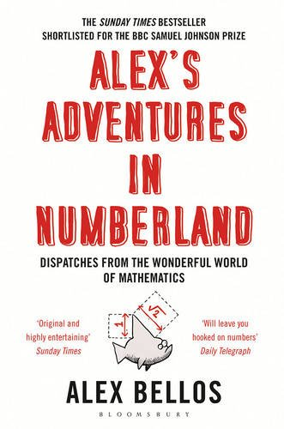
Alex’s Adventures in Numberland by Alex Bellos

The world of maths can seem mind-boggling, irrelevant and, sometimes, boring. This groundbreaking book reclaims maths from the geeks. Mathematical ideas underpin just about everything in our lives: from the surprising geometry of the 50p piece to how probability can help you win in any casino. In search of weird and wonderful mathematical phenomena, Alex Bellos travels across the globe and meets the world's fastest mental calculators in Germany and a startlingly numerate chimpanzee in Japan. Packed with fascinating, eye-opening anecdotes, Alex's Adventures in Numberland is an exhilarating cocktail of history, reportage and mathematical proofs that will leave you awestruck.

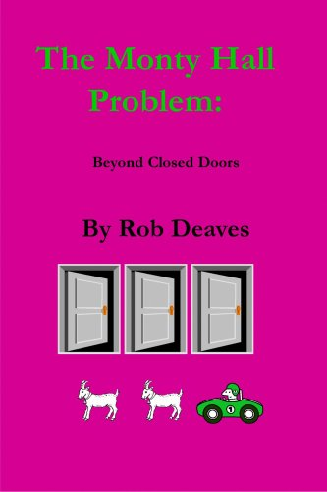
The Monty Hall Problem: Beyond Closed Doors by Rob Deaves

This short book explores the Monty Hall dilemma, a well known mathematical puzzle. The original problem, the controversy surrounding it and its solution are discussed. Further, the boundaries of the problem are expanded to consider prior knowledge and host intention. This book should be of interest to those who enjoy problem solving.

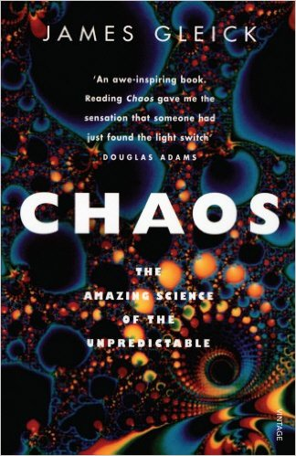
Chaos by James Gleick

Chaos is what happens when the behaviour of a system gets too complicated to predict; the most familiar example is the weather, which apparently cannot be forecast accurately more than five days ahead. This book tells the story so far in the study of this new field of Physics.

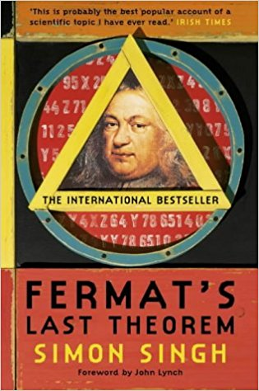Fermat's Last Theorem by Simon Singh

The story of the solving of a puzzle that has confounded mathematicians since the 17th century. In 1963, a schoolboy browsing in his local library stumbled across the world's greatest mathematical problem: Fermat's Last Theorem, a puzzle that every child can understand but which has baffled mathematicians for over 300 years. Aged just ten, Andrew Wiles dreamed that he would crack it. Wiles's lifelong obsession with a seemingly simple challenge set by a long-dead Frenchman is an emotional tale of sacrifice and extraordinary determination. In the end, Wiles was forced to work in secrecy and isolation for seven years, harnessing all the power of modern maths to achieve his childhood dream. Many before him had tried and failed, including a 18-century philanderer who was killed in a duel. An 18-century Frenchwoman made a major breakthrough in solving the riddle, but she had to attend maths lectures at the Ecole Polytechnique disguised as a man since women were forbidden entry to the school.

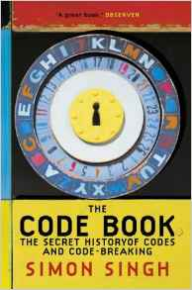The Code Book by Simon Singh

The Code Book is a history of man's urge to uncover the secrets of codes, from Egyptian puzzles to modern day computer encryptions. As in Fermat's Last Theorem, Simon Singh brings life to an astonishing story of puzzles, codes, languages and riddles that reveals man's continual pursuit to disguise and uncover, and to work out the secret languages of others. Codes have influenced events throughout history, both in the stories of those who make them and those who break them. The betrayal of Mary Queen of Scots and the cracking of the enigma code that helped the Allies in World War II are major episodes in a continuing history of cryptography. In addition to stories of intrigue and warfare, Simon Singh also investigates other codes, the unravelling of genes and the rediscovery of ancient languages and most tantalisingly, the Beale ciphers, an unbroken code that could hold the key to a 20 million dollar treasure.

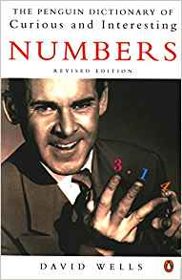The Penguin Dictionary of Curious and Interesting Numbers by David Wells

Look up 1729 to see why it is ‘among the most famous of all numbers’. Look up 0.7404 (=π18) to discover that this is the density of closely packed identical spheres in what is believed by many mathematicians (though it was at that time an unproven hypothesis) and is known by all physicists and greengrocers to be the optimal packing. Look up Graham’s number (the last one in the book), which is inconceivably big: even written as a tower of powers (999⋯) it would take up far more ink than could be made from all the atoms in the universe. It is an upper bound for a quantity in Ramsey theory whose actual value is believed to be about 6. A book to be dipped into at leisure.

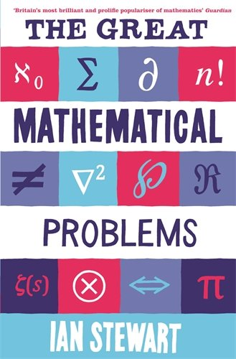The Great Mathematical Problems by Ian Stewart

There are some mathematical problems whose significance goes beyond the ordinary - like Fermat's Last Theorem or Goldbach's Conjecture - they are the enigmas which define mathematics. This book explains why these problems exist, why they matter, what drives mathematicians to incredible lengths to solve them and where they stand in the context of mathematics and science as a whole. It contains solved problems - like the Poincaré Conjecture, cracked by the eccentric genius Grigori Perelman, who refused academic honours and a million-dollar prize for his work, and problems which, like the Riemann Hypothesis, remain baffling after centuries. Stewart is the guide to this mysterious and exciting world, showing how modern mathematicians constantly rise to the challenges set by their predecessors, as the great mathematical problems of the past succumb to the new techniques and ideas of the present.

